ITEM DETAILS
Name of Item | Inter-War Shop Top Flats
Other Name/s  Former Name/s | 50-54 Campbell Parade, Bondi Beach
Item type | Built
Item group | Flat Building
Item category | Flat
Area, Group, or Collection Name | Unknown
Street number | 50-54
Street name | Campbell Parade
Suburb/town | Bondi Beach |  |  |  |  | Postcode |  |  | 2026
Local Government Area/s | Waverley
Property description | SP 13459
Location - Lat/long | Latitude | -33.893134 |  | Longitude | 151.272694
Location - AMG (if no street address) | Zone |  |  | Easting |  |  |  | Northing
Owner | Private
Current use | Residential
Former Use | Residential
Statement of significance | 50-54 Campbell Parade, Walhalla Court (c1936) is part of a group, 50-58 Campbell Parade with similar dating and stylistic character. It is a fine example of a two-storey Inter-War Art Deco flat building in a retail strip setting that is part of a group, that illustrates the key period of development of Campbell Parade, a Riviera-style promenade, and Bondi Beach.  It demonstrates the 1919 subdivision of the O’Brien Estate by the O’Brien family and the development of Campbell Parade in response to the extension of the tram to North Bondi and the development of Bondi Beach as a recreational destination during the Inter-War period.  The building represents the development of Inter-War flat buildings, an important phase in the history of Waverley which represents the 1920s-1930s development boom, a prominent period of economic prosperity and speculative development in Waverley associated with the changing demographics with a shift to living in flats.
Level of Significance | National |  | State |  |  |  | Local

DESCRIPTION
Designer

Builder/ maker | Henry O’Connell
Physical Description | 50-54 Campbell Parade, Bondi, Walhalla Court, is a two-storey flat building that dates from the Inter-War period (c1936), a key period of significance of the Bondi area. It is part of a group that reflects a Riviera-style promenade. The building displays features of the Inter-War Art Deco style including the symmetrical form and massing, stepped building, stepped parapet, decorative brickwork (now painted), parallel line motif, vertical piers, and stepped motif to the entry. The building is setback 2m from the street on a large site approximately 11 metres wide, that has been amalgamated within a retail strip setting that has retained much of its historic context. The building is in good condition despite alterations.  Elements impacting upon the integrity of the site include painting of face brick finish, replacement of original windows and doors to façade and security bars.
Physical condition  and  Archaeological potential | The building appears to be in good condition.
Construction years | Start year | 1937 | Finish year | 1937 | Circa
Modifications and dates | Site was transferred to Carinda Units Pty Ltd in 1978, and Strata Plan 13459 was registered (7196-99).

HISTORY
Historical notes | The O'Brien family's land at Bondi was subdivided for housing blocks in stages from 1881. These O'Brien subdivisions were inclusive of the northern headland of Ben Buckler (Hurd/Parry grant), and Barton's grant to the south (bounded by Dudley and Fletcher streets). The first land release coincided with the 25 acres of beachfront at Bondi being reserved for public recreation in 1882, and the commencement of the construction of the Bondi Ocean Outfall Sewer laid down Blair Street (formerly Sewer Road) from 1883. Although finally completed in 1894, the tramway to the beach had been mooted since 1882 and was partially completed, to Fletcher Street, by 1884. On the completion of the Bondi Pavilion, in 1929 the tramway was extended north from Curlewis Street to North Bondi. The completion of this extension opened up the North Bondi area for residential development, which took the form of residential flats in many instances.  The area fronting Campbell Parade between Sir Thomas Mitchell Road and Lamrock Avenue was part of the O’Brien’s land that was subdivided relatively late, in 1919; the owners then being Thomas Ormond O’Brien and the widowed Mrs Amelia Jane O’Brien – Francis O’Brien’s third wife. (John Oultram Heritage and Design, Heritage Assessment 58 Campbell Parade Bondi Beach)  50-54 Campbell Parade, Bondi comprises of Lots 2 & 3 in DP 8230.  Lots 2-5 were purchased by David Pollock Park, a contractor of Sydney in 1922. Park sold the land to George O’Carroll, a builder of Bondi in 1928 (3339-50). Frank Lugsdin, a retired grazier, purchased the site in 1931 (4492-135). In March 1937, the property was sold to Henry O’Connell, a builder of Bondi. It is likely that O’Connell built the Walhalla Court flats soon after, as the date 1937 is evident in the entry porch (4492-135). In October 1937, the property was leased to Gladys Simmons. The lease expired in 1943 and the property was sold to Robert Graham (hotel keeper) and his wife, Isabel. Graham died in 1952 (4492-135). In 1956, Thomas Prosser of Dulwich Hill, a dry cleaner, was registered proprietor. The site changed hands in 1957, to Caroline Meredith and Cynthia Goodall of Brisbane (7196-99). The site was transferred to Carinda Units Pty Ltd in 1978, and Strata Plan 13459 was registered (7196-99).  Notably, the National Trust’s Statement of Significance for its heritage listing of the Bondi Pavilion and the Bondi Beach Urban Conservation Area both note the significance of the buildings fronting Campbell Parade. The reasons are:  The scale of Bondi Beach and the pronounced functional and visual integration with its historically significant foreshore development is a rare 1920s urban landscape within the context of any city in the world.  The development of Bondi Beach has significance in the historical development of Sydney. The Bondi Beach area features some typical twenties “boomtime” architecture. The two international hotels, the Bondi and the Astra, the Spanish Revival-style Bondi Pavilion and the modest flat buildings are all evocative of Bondi becoming more cosmopolitan and Sydney siders becoming recreationally oriented towards the ocean coast.  The Statement of Cultural Significance in the 2018 CMP for the Bondi Pavilion also notes:  The Bondi Pavilion is representative of 1920s Mediterranean architectural style and its setting is representative of 1920s town planning, which in a beach front location on the scale at Bondi is now unique in Sydney. The Bondi Pavilion is a key townscape element at Bondi Beach, providing a major contribution to the townscape and character of the locality and is a key element of the Bondi Beach Cultural Landscape. The assessment of significance of site elements includes the visual and physical relationships between the Bondi Pavilion and:  • its landscaped setting in Bondi Park and  • the cultural landscape in Bondi beach, including the beach, Campbell Parade and the wider environs of Bondi Bay and  • the Bondi Surf Bathers Life Saving Club Clubhouse  Research carried out for the draft Bondi Beach Cultural Landscape CMP, submitted to the Heritage Office for endorsement in 2023, states that there are additional aspects of significance not yet captured in existing Statements of Significance and that updates are required to include the buildings that line Campbell Parade that are contemporaneous with the Pavilion and beach improvement scheme:  It became clear that Bondi Beach is valued for its sense of place as an urban beach - the result of the natural environment and successive improvement schemes and forming an integrated designed landscape. The crescent-shaped, wide, gently sloping, sandy beach is enclosed by headlands on each side, the curved sea wall, bank of parkland and contemporary buildings lining Campbell Parade.  The CMP offers a revised Statement of Significance for the Bondi Beach Cultural Landscape to be considered in future, including:  Designed with a hierarchy of buildings of complimentary architectural style, the surf pavilion was the centrepiece, with smaller surf clubs and even smaller utilitarian structure and enclosed to the west by the contemporary buildings lining Campbell Parade.  Part E of the Waverly DCP includes Site Specific Development. Part E2 addresses the Bondi Beachfront area. The Bondi Beachfront area generally surrounds the CMP study area with some small exceptions. Part E2 of the DCP contains objectives and controls for the area (public domain interface, built form, use, roofs, views, heritage conservation, infill) as well as specific objectives and built form controls for the following five Character Areas:  • Notts Avenue;  • Campbell Parade South;  • Campbell Parade;  • Campbell Parade North; and  • Ramsgate Avenue East.  Within each of these character areas the desired future character, the identified LEP heritage and other Contributory buildings are identified.

THEMES
 | National historical theme | 3 Developing local, regional and national economies  4 Building settlements, towns and cities
 | State  historical theme | Towns, suburbs and villages  Land tenure  Accommodation
 | Local  historical theme | Leisure and Recreation  Flats and Bungalows  Speculation and Subdivision

Assessment
A: Historical Significance | 50-54 Campbell Parade, Walhalla Court has historical significance at a local level as it demonstrates the 1919 subdivision of the O’Brien Estate by the O’Brien family and the development of Campbell Parade in response to the 1929 extension of the tram to North Bondi and the development of Bondi Beach as a recreational destination during the Inter-War period.  50-54 Campbell Parade, Walhalla Court, has historical significance at a local level as it represents the development of Inter-War flat buildings, an important phase in the history of Waverley which represents the 1920s-1930s development boom, a prominent period of economic prosperity and speculative development in Waverley associated with the changing demographics with a shift to living in flats.  Campbell Parade is a Riviera-style promenade.
B: Associative | To date no historic association has been identified.
C: Aesthetic significance | 50-54 Campbell Parade, Walhalla Court has aesthetic significance at a local level as a fine example of an Inter-War Art Deco flat building in a retail strip setting, that is part of a group. It is part of a group that reflect the Riviera-style promenade.  The building shows an accomplished use of Inter-War Art Deco style which features symmetrical form and massing, stepped building, stepped parapet, decorative brickwork (now painted), parallel line motif, vertical piers, stepped motif to the entry and stylised lettering.
D: Social significance | To date no social, cultural, and spiritual significance has been identified.
e) Technical/  Research significance | To date no technical significance has been identified.
f) Rarity | 50-54 Campbell Parade, Walhalla Court is not rare in Waverley.
g) Representative-ness | 50-54 Campbell Parade, Walhalla Court, has representative significance at a local level as a fine example of an Inter-War Art Deco flat building in a retail strip setting, that illustrates the key period of development of Campbell Parade and Bondi Beach.
Integrity | The building has been altered.

HERITAGE LISTINGS
Heritage listing/s | Draft Waverley LEP 2012

INFORMATION SOURCES
Type | Author/Client | Title | Year | Repository
 | Waverley Council | Waverley Heritage Policy | 2007
 | Waverley Council | Waverley Heritage Study | 1993
 | Perumal Murphy Pty Ltd | Waverley Heritage Study | 1990
 | John Oultram | Heritage and Design, Heritage Assessment 58 Campbell Parade Bondi Beach
 |  | Certificate of Title, Vol 3339 Fol 50 |  | NSW Land Registry Services
 |  | Certificate of Title, Vol 4492 Fol 135 |  | NSW Land Registry Services
 |  | Certificate of Title, Vol 7196 Fol 99 |  | NSW Land Registry Services

RECOMMENDATIONS
Recommendations

SOURCE OF THIS INFORMATION
Name of study or report | Heritage Policy by Waverley Council reviewed by Architectural Projects 2023 |  | Year of study or report
Item number in study or report

Author of study or report
Inspected by
NSW Heritage Manual guidelines used? |  |  |  | Yes |  | No
This form completed by |  |  |  | Date

IMAGES

Image caption | 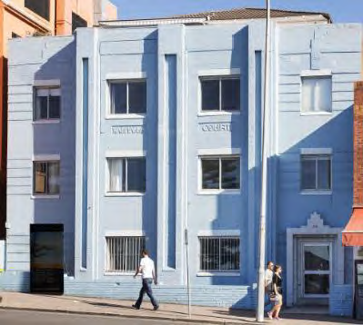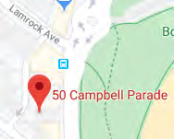
Image year |  | Image by | Google Maps | Image copyright holder

Image caption | 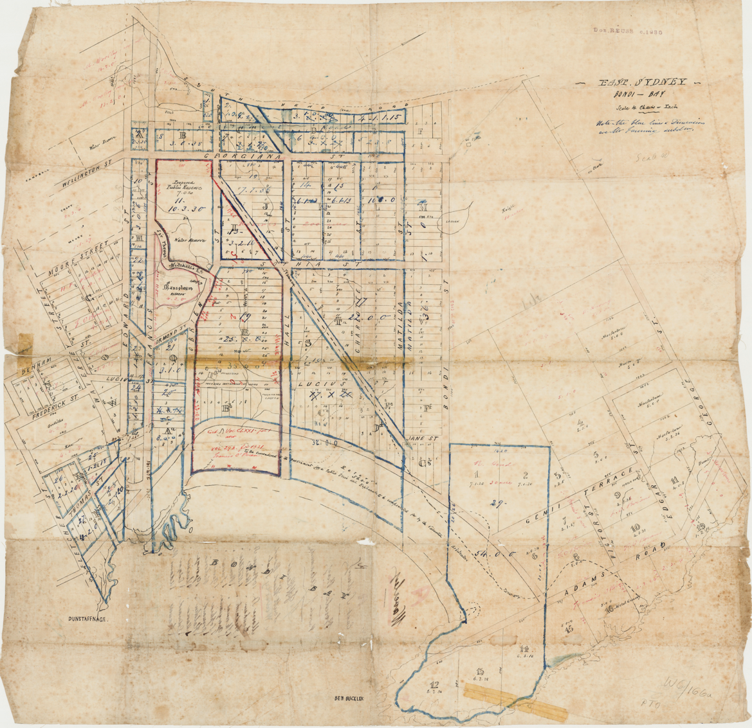
Image year | Undated | Image by | State Library of New South Wales | Image copyright holder

Image caption | 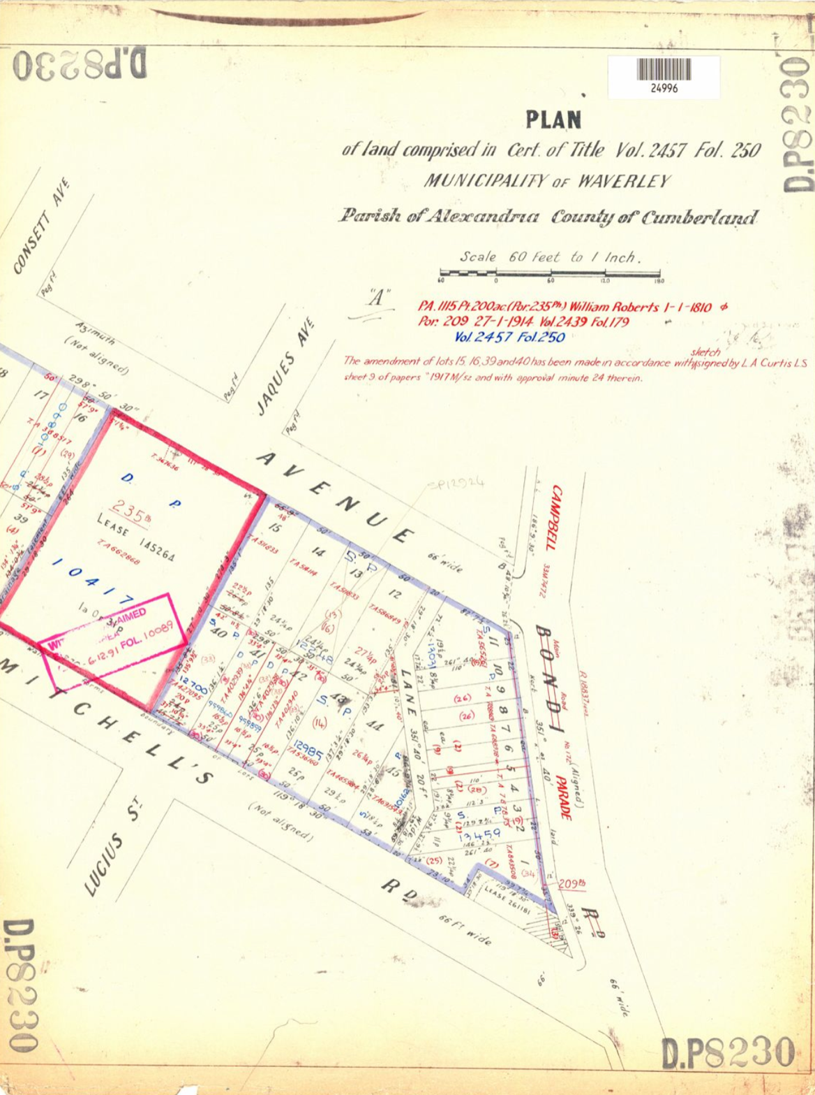
Image year | Undated | Image by | LPI | Image copyright holder

Image caption | 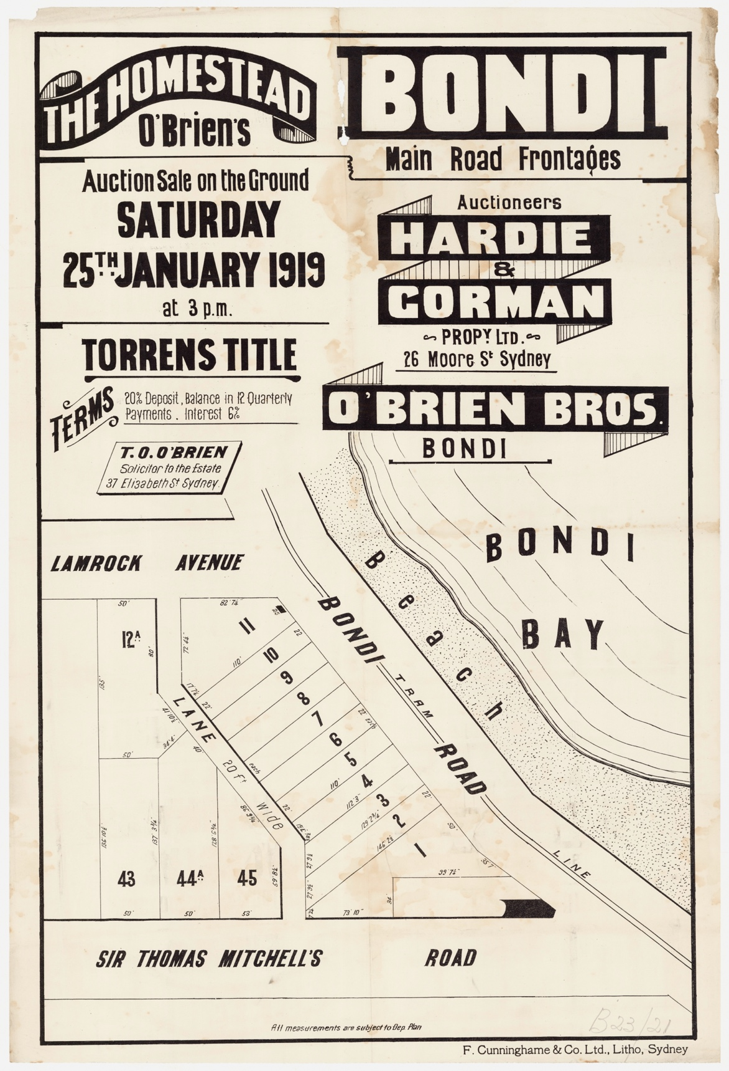
Image year | 1919 | Image by | State Library of New South Wales | Image copyright holder

